**Answer key**

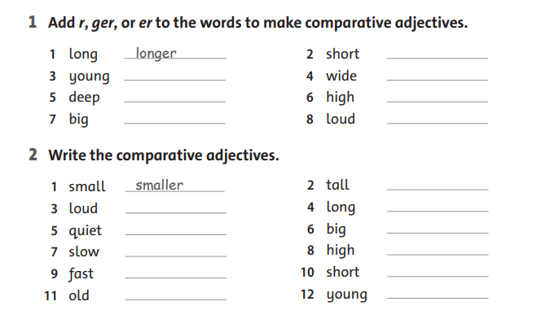

**higher**

**younger**

**shorter**

**bigger**

**taller**

**older**

**faster**

**longer**

**slower**

**quieter**

**louder**

**shorter**

**louder**

**wider**

**higher**

**bigger**

**deeper**

**younger**

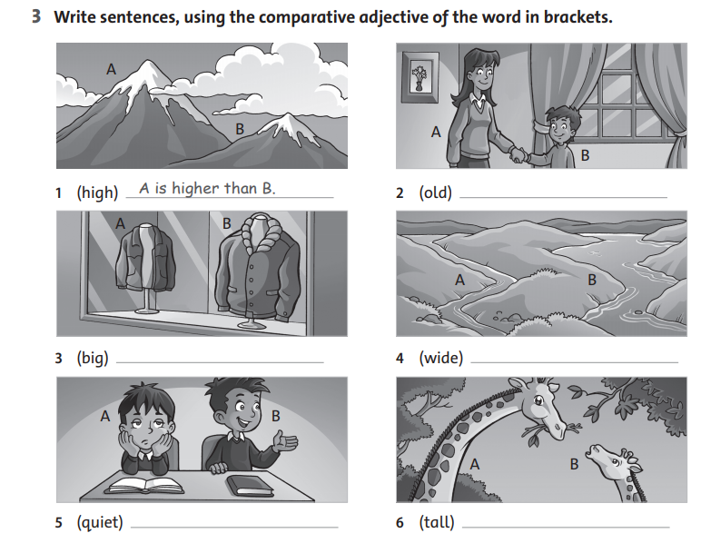

**A is quieter than B**

**A is taller than B**

**B is wider than A**

**B is bigger than A**

**A is older than B**

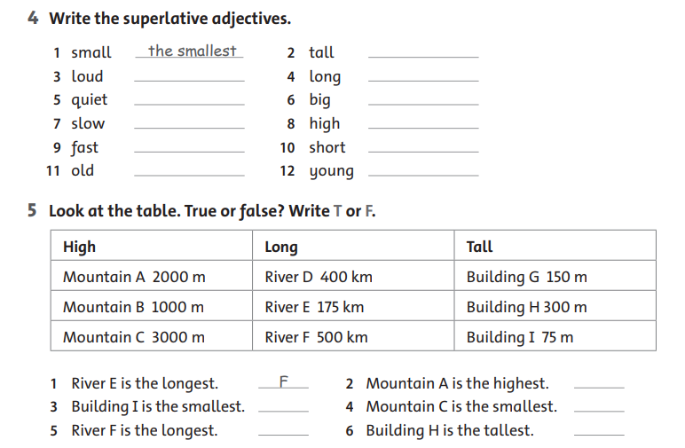

**T**

**T**

**F**

**T**

**F**

**the youngest**

**the shortest**

**the higest**

**the biggest**

**the longest**

**the tallest**

**the oldest**

**the fastest**

**the slowest**

**the quietest**

**the loudest**

**6**

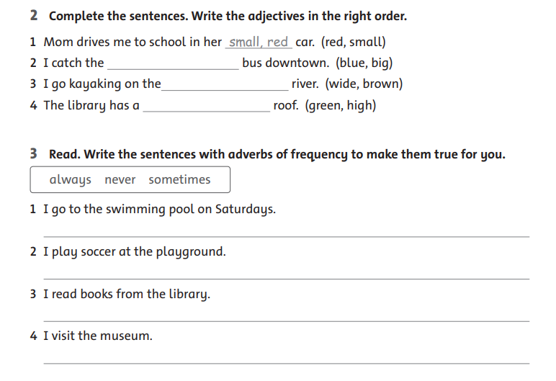

**I sometimes visit the museum.**

**I always read books fromm the library**

**I sometimes play soccer at the playground.**

**I never go to the swimmning pool on Saturdays.**

**high, green**

**wide, brown**

**big, blue**

**7**

**9**